



Name : Hafsa Shahid
Reg no : B25F34CYS101
Program : Cybersecurity
Instructor’s name: Hassan Ali
Date Submitted : 13 / 07 / 26
Deadline : 13 / 07 / 26
Assignment Report # 6

\

• INTRODUCTION •
In this task we learned about a few efficient commands for managing your operating system. The main objective was to run a few commands on the terminal. We were given an assignment at the end; it goes as follows.

Assignments Tasks:

Task : Run Commands, Update the OS. Check disk usage. Check memory usage. Manage a service. Monitor running processes.

• TASK •
Task : Run Commands, Update the OS. Check disk usage. Check memory usage. Manage a service. Monitor running processes.

Steps Followed:
- Run command for Updating the OS.
- Run command for Checking Disk Usage.
- Run command for Checking Memory Usage.
- Run command for Manage a Service.
- Run command for Monitor Running Processes.

• STEP # 01 •
Step # 01 : Run command for Updating the OS.
- Open terminal in kali linux.
- Type the command sudo apt update && sudo apt upgrade -y.
- Output is as follows.
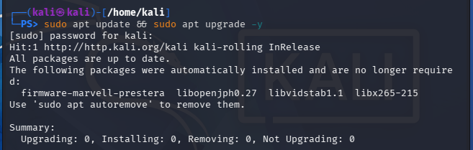

Step #01: Command sudo apt update && sudo apt upgrade -y
This will first check for any packages then update each one.

• STEP # 02 •
Step # 02 : Run command for Checking Disk Usage.
- Open terminal in kali linux.
- Type the command df -h.
- Output is as follows.
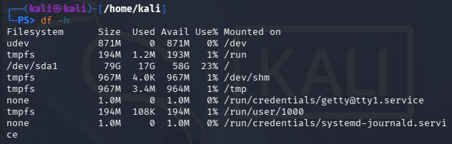

Step #02: Command df -h

This will display disk usage.
• STEP # 03 •
Step # 03 : Run command for Checking Memory Usage.
- Open terminal in kali linux.
- Type the command free -h.
- Output is as follows.
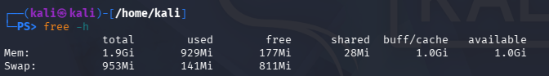

Step #03: Command free -h
This will display current memory RAM.
• STEP # 04 •
Step # 04 : Run command for Manage a Service.
- Open terminal in kali linux.
- Type the command sudo systemctl start/stop/status apache2.
- Output is as follows.
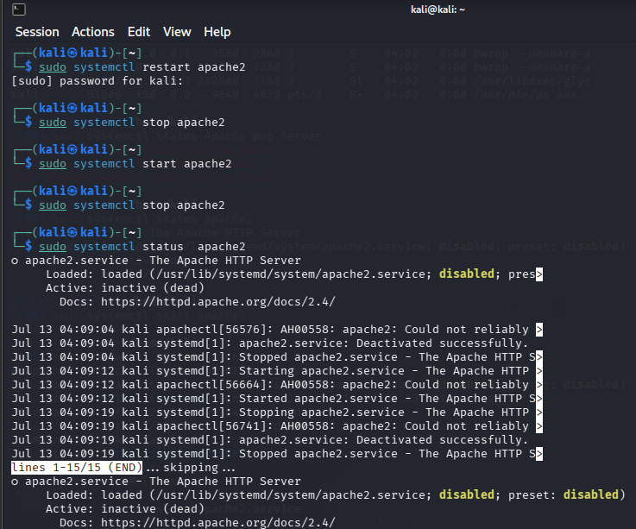

Step #04: Command sudo systemctl start/stop/status apache2
This will perform the operation depending on the command.
• STEP # 05 •
Step # 05 : Run command for Monitor Running Processes.
- Open terminal in kali linux.
- Type the command ps aux.
- Output is as follows.
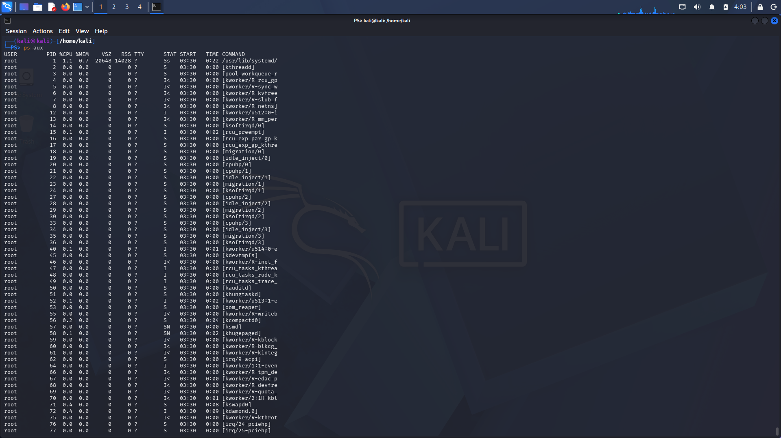

Step #05: Command ps aux
This will display all running processes with their info.

Assignment Conclusion:
In this assignment we ran some commands in the kali linux terminal to get a better understanding of managing an OS from the terminal. This increased and polished my ability to use and learn more about cybersecurity.

• The End •

